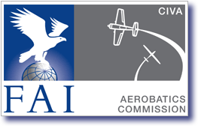
The CIVA
International Judging Seminar
[place and date of the seminar]
Agenda
Module 0 | Module 3
Thinking about thinking … | Handling mistakes
Module 1 | Pilot errors …
Introduction | Use of the video for Matters of Fact
Topics to be covered | The Positioning Mark
A review of the Basics | Video - How observant are you?
Know the Rules | Some hot tips
Changes for 2023 | Judging the 4-minute Freestyle
Presentation - Zoom round the Rules | Judges Break #3
The Zeros | Module 4
Judges Break #1 | FairPlay and ACRO
Module 2 | What they do
Fun test - Angles and Downgrades | How they do it
The judging team | The Judging Analyses
Creating time for the Judge:
Judge ONLY what you see
• The Team – Judge, Caller and Scribe | Question Time
• Angles and loops, Push and Pull | Pilots And Judging Issues
Video – the WAC 2011 Free Unknown | Summary
Marking-up the Form-B (or C) | Practical Judging at the Airfield
Practice Calling
Judges Break #2
Useful information:
The CIVA-News website: http://www.civa-news.com
The FAI / CIVA website: https://www.fai.org/aerobatics/
CIVA Rules are at: https://www.civanews.com/the-civa-document-store/
and https://www.fai.org/civa-documents and click Sporting Code

